|  |
| --- |
| **LAPORAN PRAKTIKUM JARINGAN KOMPUTER**  **13.3.1**  **Packet Tracer - Use ICMP to Test and Correct Network Connectivity** |
|  |
| **Agus Pranata Marpaung**  **13323033**  **DIII TEKNOLOGI KOMPUTER** |
| **INSTITUT TEKNOLOGI DEL**  **FAKULTAS VOKASI** |

**Judul Praktikum**

|  |  |  |
| --- | --- | --- |
| **Minggu/Sesi** | : | V/3 |
| **Kode Mata Kuliah** | : | 4332101 |
| **Nama Mata Kuliah** | : | JARINGAN KOMPUTER |
| **Setoran** | : | Jawaban dalam bentuk *softcopy* |
| **Batas Waktu Setoran** | : | *Sesi Praktikum Selanjutnya* |
| **Tujuan** | : | 1. Mahasiswa dapat melakukan percobaan untuk memastikan keterhubangan perangkat jaringan dan menganalisis header pada protokol TCP dan UDP pada layer transport. |

**Petunjuk**



**Packet Tracer - Use ICMP to Test and Correct Network Connectivity**

**Addressing Table**

|  |  |  |  |  |
| --- | --- | --- | --- | --- |
| **Device** | **Interface** | **Address** | **Mask/Prefix** | **Default Gateway** |
| RTR-1  *RTR-1*  *RTR-1*  *RTR-1*  *RTR-1*  *RTR-1* | G/0/0/0  *G/0/0/0* | 192.168.1.1 | 255.255.255.0 | N/A |
| 2001:db8:4::1 | /64 | N/A |
| S0/1/0  *S0/1/0* | 10.10.2.2 | 255.255.255.252 | N/A |
| 2001:db8:2::2 | /126 | N/A |
| S0/1/1  *S0/1/1* | 10.10.3.1 | 255.255.255.252 | N/A |
| 2001:db8:3::1 | /126 | N/A |
| RTR-2  *RTR-2*  *RTR-2*  *RTR-2* | G/0/0/0 | 10.10.1.1 | 255.255.255.0 | N/A |
| G0/0/1 | 2001:db8:1::1 | /64 | N/A |
| S0/1/0 | 10.10.2.1 | 255.255.255.252 | N/A |
| 2001:db8:2::1 | /126 | N/A |
| RTR-3  *RTR-3*  *RTR-3*  *RTR-3* | G0/0/0 | 10.10.5.1 | 255.255.255.0 | N/A |
| G0/0/1 | 2001:db8:5::1 | /64 | N/A |
| S0/1/0  *S0/1/0* | 10.10.3.2 | 255.255.255.252 | N/A |
| 2001:db8:3::2 | /126 | N/A |
| PC-1 | NIC | 10.10.1.10 | 255.255.255.0 | 10.10.1.1 |
| Laptop A | NIC | 10.10.1.20 | 255.255.255.0 | 10.10.1.1 |
| PC-2 | NIC | 2001:db8:1::10 | /64 | fe80::1 |
| PC-3 | NIC | 2001:db8:1::20 | /64 | fe80::1 |
| PC-4 | NIC | 10.10.5.10 | 255.255.255.0 | 10.10.5.1 |
| Server 1 | NIC | 10.10.5.20 | 255.255.255.0 | 10.10.5.1 |
| Laptop B | NIC | 2001:db8:5::10 | /64 | fe80::1 |
| Laptop C | NIC | 2001:db8:5::20 | /64 | fe80::1 |
| Corporate Server  *Corporate Server* | NIC  *NIC* | 203.0.113.100 | 255.255.255.0 | 203.0.113.1 |
| 2001:db8:acad::100 | /64 | fe80::1 |

**Objectives**

In this lab you will use ICMP to test network connectivity and locate network problems. You will also correct simple configuration issues and restore connectivity to the network.

* Use ICMP to locate connectivity issues.
* Configure network devices to correct connectivity issues.

**Background**

Customers have been complaining that they can’t reach some network resources. You have been asked to test connectivity in the network. You use ICMP to find out which resources are unreachable and the locations from which they can’t be reached. Then, you use trace to locate the point at which network connectivity is broken. Finally, you fix the errors that you find to restore connectivity to the network.

**Instructions**

All hosts should have connectivity to all other hosts and the Corporate Server.

* Wait until all link lights are green.
* Select a host and use ICMP ping to determine which hosts are reachable from that host.
* If a host is found to be unreachable, use ICMP trace to locate the general location of the network errors.
* Locate the specific errors and correct them.

**Jawaban:**

1. PC-1 ke Corporate Server dengan address 203.0.113.100

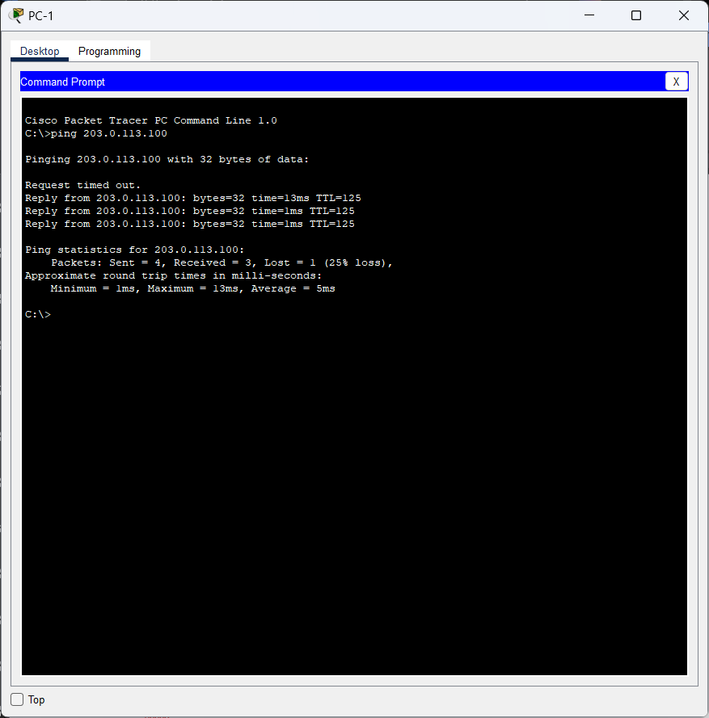

1. Laptop A ke Corporate Server dengan address 203.0.113.100

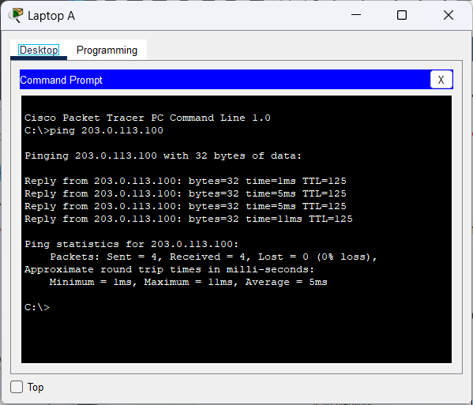

1. PC-2 ke Corporate Server dengan address 2001:db8:acad::100

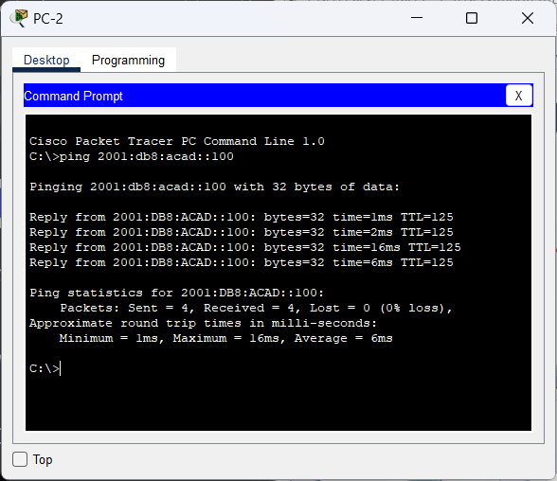

1. PC-3 ke Corporate Server dengan address 2001:db8:acad::100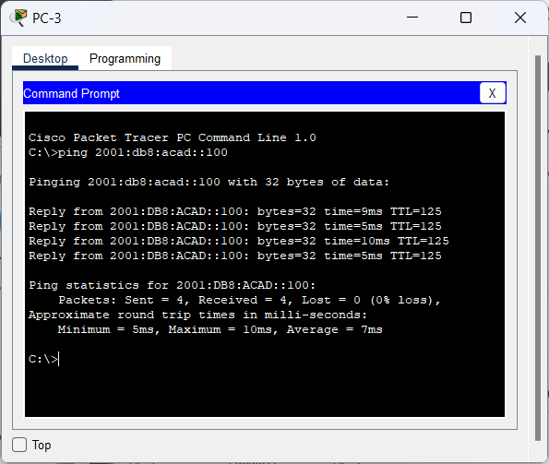
2. PC-4 ke Corporate Server dengan address 203.0.113.100

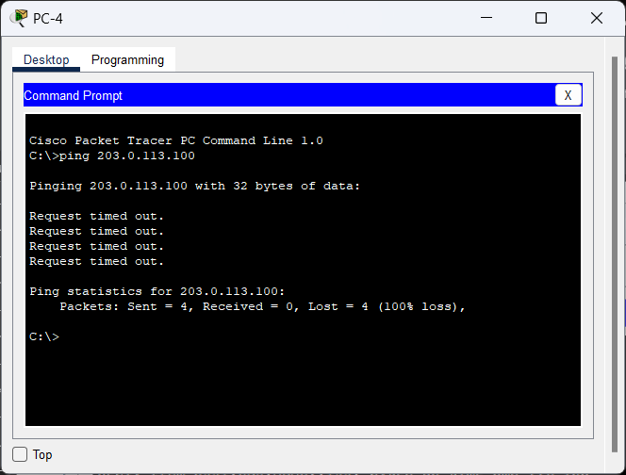

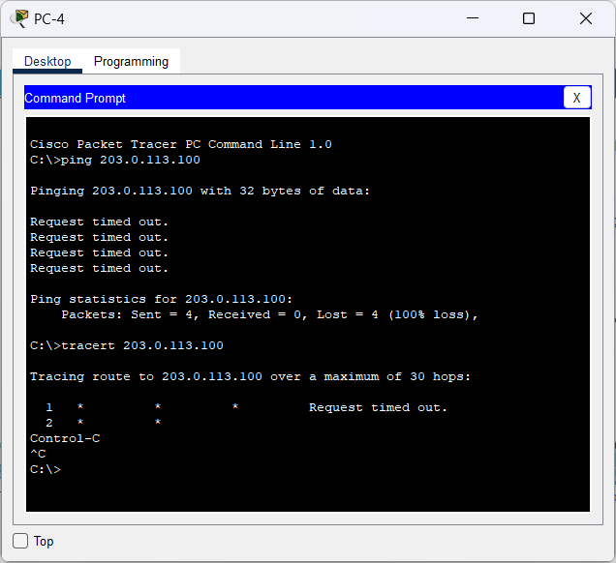

Karena waktu permintaannya telah habis, kita akan melakukan pengecekan pada IP Configuration. Ketika dicek dibagian **Default Gateway,** addressnya bermasalah sehingga diperbaiki jadi 10.10.5.1

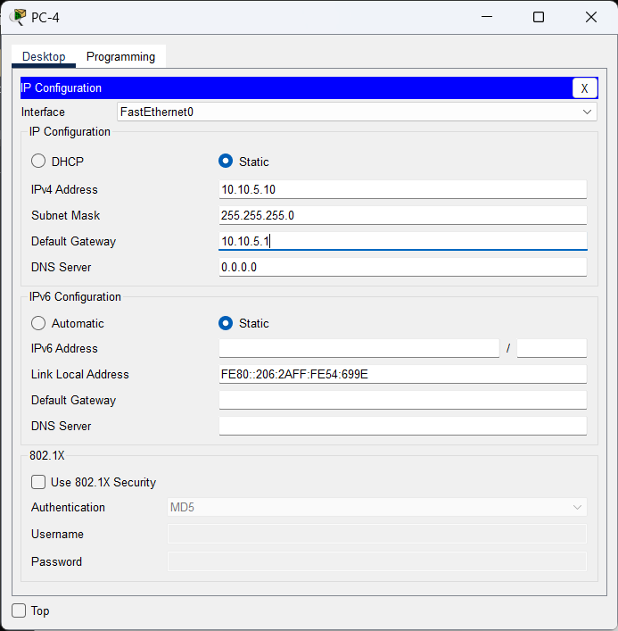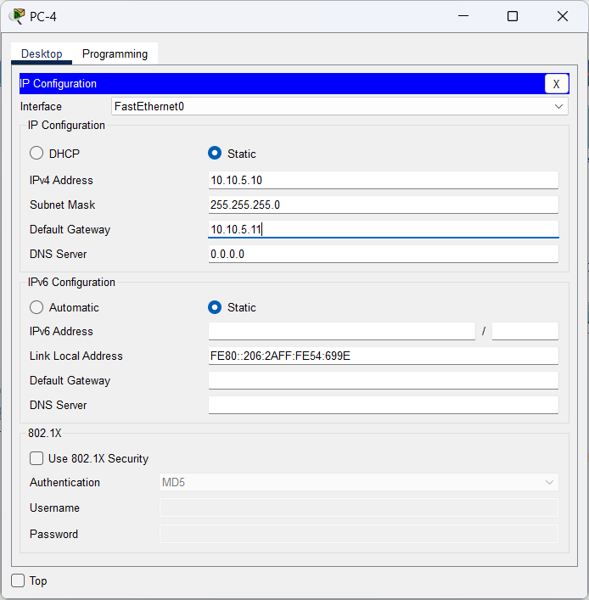

Setelah diperbaiki, kita akan lakukan ping dan tracer ke Corporate Server.

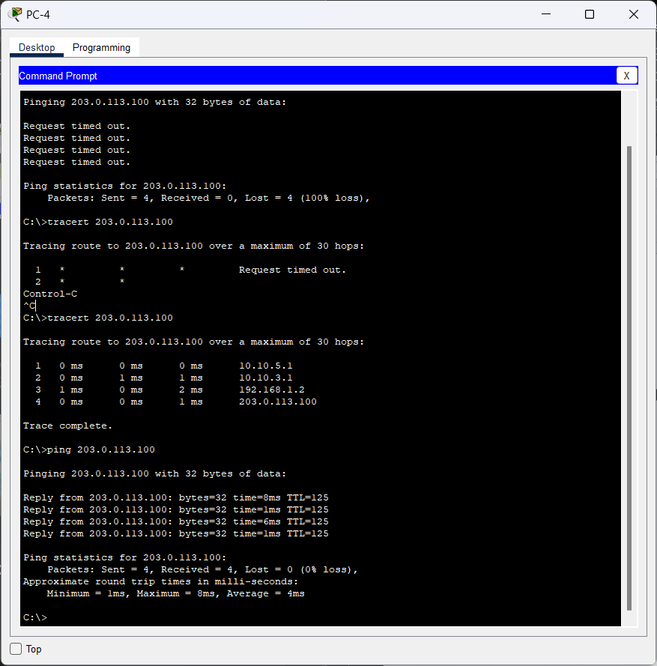

1. Server1 ke Corporate Server

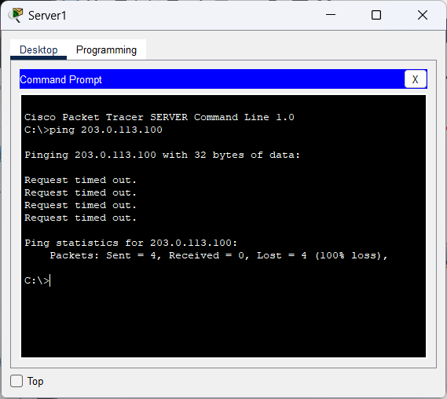

Karna disini ping nya tidak berhasil, kita akan lakukan perubahan pada konfigurasinya sesuai dengan **Addressing table** dan kita ubah jadi **Static**.

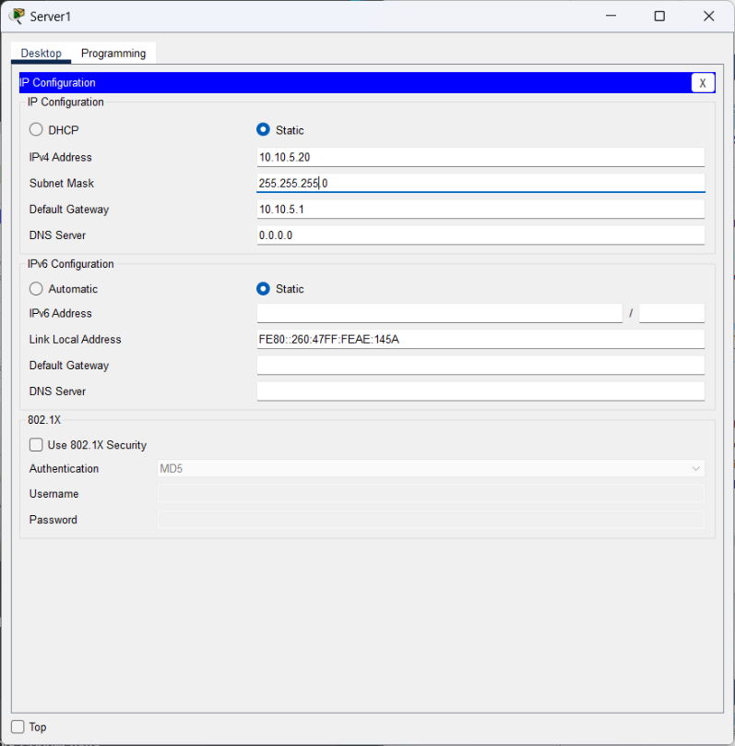

Setelah dilakukan perubahan konfigurasi, kita lakukan ping ke **Corporation Server.** Dan hasilnya bisa dilakukan ping ke **Corporation Server**.

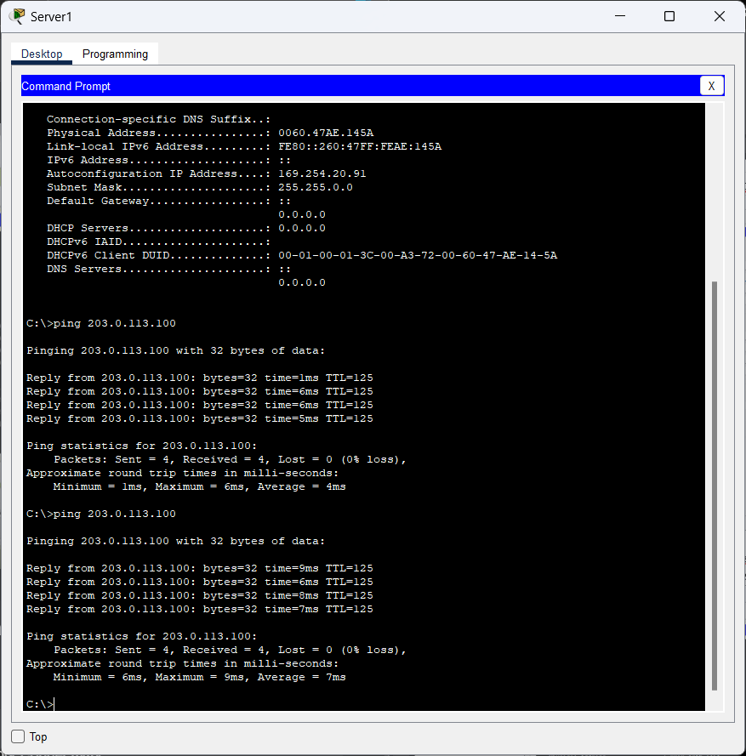

1. Laptop B ke Corporate Server

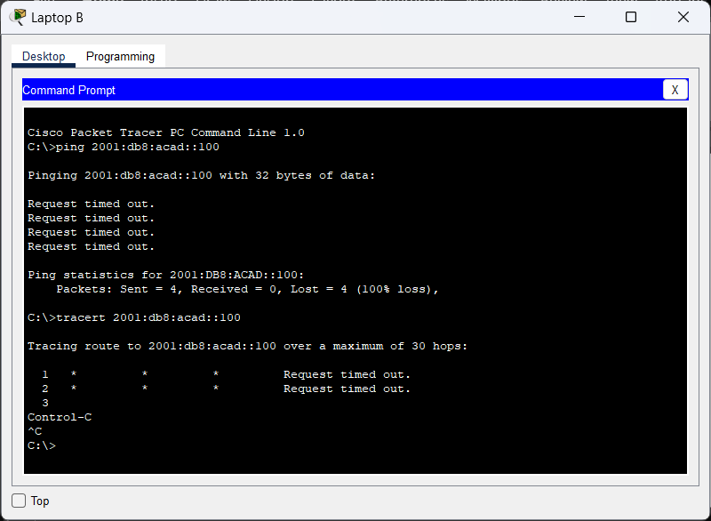

Kita akan lakukan pengecekan pada RTR-3 untuk menampilakn **ipv6**

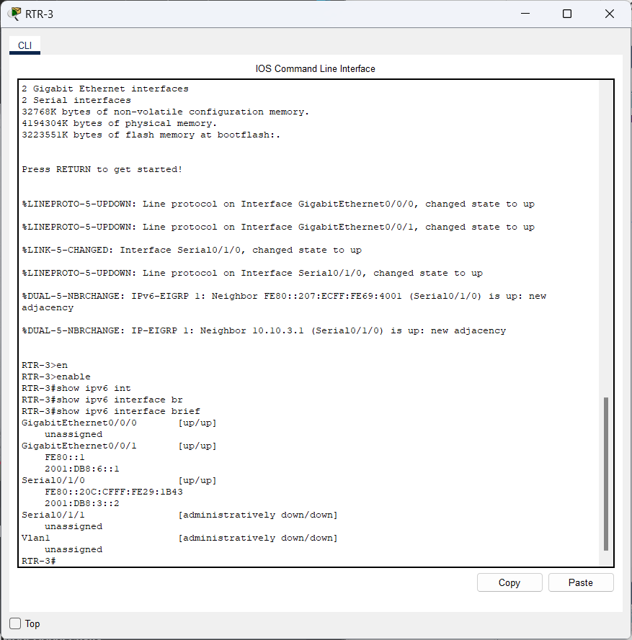

Kemudian, kita akan menghapus dan menambahkan **ipv6 address** pada RTR-3

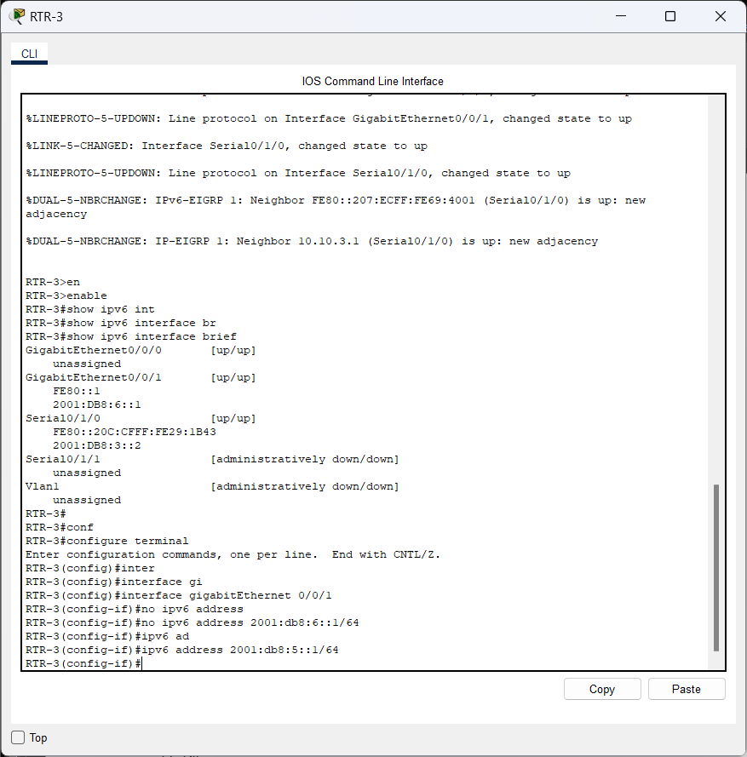

Setelah itu, kita klik Laptop B dan lakukan tracert dan ping ke **Corporate Server** dengan address 2001:db8:acad::100.

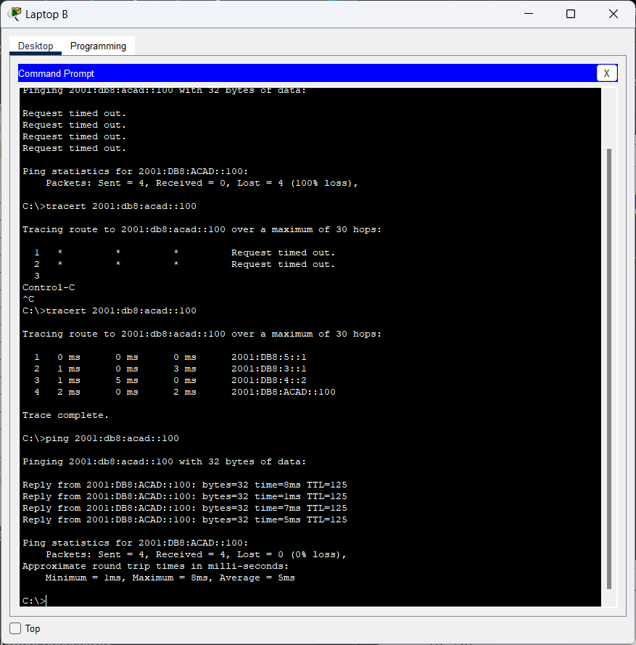

1. Laptop C ke Corporate Server

